**DATA SCIENCE TOOLBX: PYTHON PROGRAMMING**

**PROJECT REPORT**

(Project Semester January-April 2025)

***Vrinda Store Data Analysis***

Submitted by

[Your Name]

Registration No: -

Section: -



Programme -B.Tech. CSE

Course Code: - INT375

Under the Guidance of

**[Teacher name]**

**UID: -**

**Discipline of CSE/IT**

**Lovely School of Computer Science and Engineering**

**Lovely Professional University, Phagwara**



**DECLARATION**

I, your name , student of B.Tech. CSE under CSE/IT Discipline at, Lovely Professional University, Punjab, hereby declare that all the information furnished in this project report is based on my own intensive work and is genuine.

Date: 12-04-2025 Signature

Registration No. 1

**CERTIFICATE**

This is to certify that **[Your name]** bearing Registration no. **[Registration No]** has completed INT375 project titled, **“Vrinda Store Data Analysis”** under my guidance and supervision. To the best of my knowledge, the present work is the result of his/her original development, effort, and study.

**[Teacher name]**

**Assistant Professor**

**School of Computer Science and Engineering**

Lovely Professional University

Phagwara, Punjab.

Date: 12-04-2025

**ACKNOWLEDGEMENT**

I want to take a moment to express my deep appreciation for the support I have received from everyone, either directly or indirectly, for enabling me to finish this project successfully. To start, I am grateful to **[Teacher name]** for his guidance, feedback, and steady support during this project.

His guidance allowed not only academic support but also a wealth of moral support when I needed help staying on track and maintaining my motivation. I would also like to express my gratitude to **Lovely Professional University** for their example and support in offering a learning experience that fosters innovation, critical thinking, and practical application.

The resources and infrastructure they provided were significant factors that enabled me to finish the project. I need to thank my family and close friends for being my backbone throughout the project. Their understanding, optimism, and faith in me provided support, especially as I experienced self-doubt and/or pressure.

Finally, I thank the individuals who provided support through growth, learning and inspiration, and hope they realize that this project does not only indicate the summation of technical knowledge and learning, but is a personal accomplishment in and of itself, that indicates growth, perseverance, and passion.

**TABLE OF CONTENT**

1. **Introduction**
2. **Source Of Dataset**
3. **Exploratory Data Analysis (EDA)**
4. **Analysis of Dataset**
   1. **Introduction**
   2. **General Description**
   3. **Specific Requirements, functions, and formulas**
   4. **Analysis Results**
   5. **Visualisation**
5. **Conclusion**
6. **Future Scope**
7. **References**
8. **LinkedIn Post**

**1. INTRODUTION**

In today's retail landscape, data-driven decision making has become essential for businesses to thrive in increasingly competitive markets. The ability to extract meaningful insights from sales data can significantly impact strategic planning, resource allocation, and overall business performance. This comprehensive analysis of Vrinda Store's sales data aims to uncover critical patterns, customer behaviours, and operational insights that can drive business growth and optimization.

Vrinda Store, like many retail operations, collects substantial amounts of transactional data that contains valuable information about customer demographics, purchasing patterns, geographical distribution of sales, channel effectiveness, and product category performance. However, raw data alone does not provide actionable intelligence. Through systematic analysis using statistical methods and data visualization techniques, we can transform this data into strategic knowledge that supports informed business decisions.

This report presents a multi-faceted analysis of Vrinda Store's sales data, examining relationships between variables such as gender, location, product categories, sales channels, and order status. By employing hypothesis testing methodology alongside descriptive statistics and visualization techniques, we aim to validate or challenge assumptions about the business and identify statistically significant patterns that may influence future strategies.

The analysis utilizes Python's powerful data manipulation and visualization libraries including Pandas, NumPy, Matplotlib, Seaborn, and SciPy to process, analyze, and visually represent the data. Through exploratory data analysis, we first understand the structure and characteristics of the dataset, followed by cleaning procedures to ensure data quality and reliability. Subsequently, we employ hypothesis testing to examine specific relationships and dependencies within the data. Finally, visual representations help communicate key findings effectively.

This report is structured to provide a comprehensive understanding of Vrinda Store's sales performance, beginning with data exploration and preparation, followed by in-depth analysis and hypothesis testing, and concluding with actionable insights and recommendations. The findings from this analysis will enable Vrinda Store to optimize their inventory management, marketing strategies, channel allocation, and customer targeting based on empirical evidence rather than intuition.

**2. SOURCE OF DATASET**

The dataset utilized in this analysis originates from Vrinda Store's operational database, containing comprehensive sales records compiled in an Excel format. The file, named "Vrinda Store Data Analysis.xlsx," serves as the primary data source for this project and encompasses detailed information regarding customer transactions, product details, and order processing metrics.

The dataset was accessed and processed directly from a local file path (E:\Python Project 1\Vrinda Store Data Analysis.xlsx) using Python's data analysis libraries. This approach ensured data integrity by working with primary source information rather than pre-processed or secondary data sources. As part of the standard data science workflow, appropriate checks were implemented to ensure successful data loading, with error handling mechanisms in place to address potential issues such as file not found errors or other exceptions that might arise during the data import process.

This retail dataset appears to be a comprehensive collection of transactional records capturing various dimensions of Vrinda Store's operations. Based on the code analysis, the dataset contains numerous attributes including but not limited to:

* Customer demographics (Gender, Age)
* Transaction details (Amount, Quantity, Date)
* Geographic information (Ship State)
* Product categorization (Category)
* Sales channel information (Channel)
* Order processing information (Status)

The dataset represents a real-world business scenario with typical challenges found in retail data, including inconsistent formatting, missing values, and varying data types that required cleaning and standardization. For instance, the gender field contained variations such as "women," "w," and "female" that needed to be standardized to a consistent format. Similarly, the quantity field included both numeric and text representations (e.g., "one" instead of 1) that required conversion to ensure analytical consistency.

The temporal scope of the data is not explicitly stated in the provided code but appears to include sufficient records to enable meaningful temporal analysis, given the date field is processed and converted to datetime format. The dataset's size is substantial enough to support robust statistical hypothesis testing, as evidenced by the successful execution of t-tests, ANOVA, and chi-square tests.

While the precise origin and collection methodology of the data is not explicitly documented in the code, the dataset structure aligns with standard point-of-sale (POS) and order management systems commonly used in retail environments. The data's format and content suggest a comprehensive capture of business operations, making it suitable for the analytical objectives outlined in this project.

**Dataset URL**: <https://github.com/rishabhnmishra/Excel_Vrinda_Store_Analysis/blob/main/Vrinda%20Store%20Data%20Analysis.xlsx>

**3. Exploratory Data Analysis (EDA)**

**Exploratory Data Analysis (EDA)** forms the foundational step in understanding the Vrinda Store dataset, uncovering its structure, identifying patterns, and preparing it for subsequent analysis. The EDA process began with loading the dataset using Pandas and examining its basic properties to gain preliminary insights into the data characteristics and quality issues that needed addressing.

Upon initial inspection, several data quality issues were identified that required cleaning and transformation. The dataset contained inconsistencies in formatting, missing values, and mixed data types that could potentially impact the analysis results. The cleaning process was methodically implemented through the clean_data() function, which addressed these issues systematically to ensure data reliability and consistency.

One of the primary data quality issues addressed was the standardization of categorical variables. The Gender field, for instance, contained multiple representations for male and female categories (such as 'women', 'w', 'female' for females) that were normalized to consistent values ('Male' and 'Female'). Similarly, the Channel field contained inconsistent formatting and was standardized by stripping whitespace, applying title case, and replacing empty strings with NaN values.

Numeric fields also required careful attention. The Quantity field presented a unique challenge as it contained both numeric values and text representations (e.g., 'one', 'two', 'three'), necessitating a mapping function to convert these to their corresponding numeric values. The Age and Amount fields were converted to numeric format using Pandas' to_numeric() function with appropriate error handling to ensure clean conversion.

Date fields were standardized by converting to Pandas datetime objects, ensuring temporal analysis could be performed accurately. This standardization allowed for potential time-based analyses such as seasonal trends or temporal patterns in sales performance.

Beyond basic cleaning, the EDA process included the creation of derived features to enhance analytical capabilities. Notably, an Age Group category was created to segment customers into meaningful demographic groups (Teenager, Adult, Senior), enabling more nuanced analysis of purchasing patterns across age segments.

The dataset's structure and quality were verified after cleaning through detailed information summaries. These summaries provided insights into the dataset's dimensions, column data types, memory usage, and the presence of any remaining missing values. This verification step ensured that the cleaned dataset was suitable for subsequent analysis and hypothesis testing.

The EDA process also included preliminary visual exploration (not explicitly detailed in the provided code but implied by the visualization functions) to identify distribution patterns and potential relationships between variables. These visual explorations likely informed the selection of specific hypothesis tests and visualization approaches used in the later analysis stages.

**4. Analysis of Dataset**

**4.1. Introduction**

The analysis of Vrinda Store's dataset represents a systematic approach to extract actionable business intelligence from retail transaction data. This section delves into the methodologies employed to analyze the dataset, the specific objectives driving the investigation, and the technical implementation details. The analysis framework combines descriptive statistics, inferential statistics through hypothesis testing, and data visualization to provide a comprehensive understanding of the business performance across multiple dimensions.

The analytical approach was designed to address both exploratory questions about the dataset and to test specific hypotheses regarding customer behavior, product performance, and sales channel effectiveness. By employing a combination of statistical tests and visual analytics, this analysis aims to uncover patterns that may not be immediately apparent from cursory examination of the raw data.

Three core hypotheses were formulated to investigate key business questions:

1. Whether there exists a significant difference in sales amounts between gender demographics
2. Whether sales performance varies significantly across the top product categories
3. Whether there is a statistical association between sales channels and order status

These hypotheses were selected to address critical business questions that could influence marketing strategies, inventory management, and channel optimization. The statistical significance of these relationships provides a foundation for evidence-based decision making rather than intuition-led approaches.

Beyond hypothesis testing, the visual analysis component aimed to explore five key business objectives:

1. Geographic distribution of sales to identify top-performing regions
2. Gender-based sales distribution to understand demographic performance
3. Category-wise sales distribution to identify product performance
4. Channel-wise order volume to evaluate sales channel effectiveness
5. Order status breakdown to assess fulfillment efficiency

This comprehensive analytical framework ensures that both statistical rigor and business relevance are maintained throughout the investigation. The findings from this analysis provide Vrinda Store with validated insights that can directly inform strategic decisions across multiple business functions.

**4.2. General Description**

The analysis of Vrinda Store's dataset involves a comprehensive examination of retail sales data using a robust Python-based analytical framework. The analytical approach combines data cleaning, exploratory analysis, statistical hypothesis testing, and visualization techniques to extract meaningful insights from the raw transactional data.

The dataset analysis was implemented using a modular code structure consisting of four primary functions: load_data() for importing the dataset, clean_data() for data preparation and transformation, hypothesis_testing() for statistical analysis, and visualize_data() for creating graphical representations of key findings. This modular approach ensures code maintainability, reusability, and clarity in the analytical process.

The data preparation phase involved several critical transformations to ensure analytical consistency. Categorical variables such as Gender and Channel were standardized to eliminate variations in representation. Numeric fields including Age, Amount, and Quantity were normalized to ensure proper calculation during analysis. Date fields were converted to appropriate datetime format to enable temporal analysis if needed. Additionally, derived features such as Age Group were created to facilitate demographic segmentation.

The core analytical component utilized statistical hypothesis testing to investigate key business questions. Three distinct statistical tests were implemented:

1. Independent samples t-test to compare sales amounts between gender groups, with preliminary testing for variance equality using Levene's test
2. One-way ANOVA to compare sales performance across top product categories, again with variance testing
3. Chi-square test of independence to evaluate the association between sales channels and order status

These statistical tests provide empirical evidence for or against the hypothesized relationships, allowing for evidence-based business decisions.

The visualization component leverages Matplotlib and Seaborn libraries to create five distinct visualizations addressing key business metrics:

1. A bar chart showing total sales by ship state for the top 10 performing states
2. A pie chart illustrating sales distribution by gender
3. A bar chart displaying sales distribution across product categories
4. A count plot showing order volume across different sales channels
5. A pie chart breaking down orders by status

The analysis employs various data manipulation techniques using Pandas and NumPy, including grouping operations, aggregations, filtering, and transformations. Special attention was given to data visualization aesthetics, with custom color palettes, appropriate labels, and formatting of axis values (such as displaying large numbers in 'K' format) to enhance readability and interpretation.

The entire analytical workflow was orchestrated through a main function that sequentially executes the data loading, cleaning, hypothesis testing, and visualization components, ensuring a systematic and reproducible analysis process.

**4.3. Specific Requirements, functions, and formulas**

The Vrinda Store data analysis project required a comprehensive set of technical implementations to achieve its analytical objectives. This section details the specific requirements, functions, and formulas employed throughout the analysis process.

**Data Loading Requirements:** The load_data() function implements robust exception handling to manage potential file access issues. It utilizes Pandas' read_excel() method with three distinct error handling scenarios: successful data loading, file not found errors, and general exceptions. This approach ensures graceful handling of data access issues while providing informative feedback.

**Data Cleaning Requirements:** The clean_data() function addresses multiple data quality challenges:

1. Column renaming to standardize format (removing trailing spaces)
2. Gender standardization using a custom clean_gender() function that maps various representations to standardized values
3. Quantity field normalization using a dictionary mapping (qty_map) to convert text representations to numeric values
4. Channel standardization using string methods for consistent formatting
5. Type conversion for numeric and date fields using pd.to_numeric() and pd.to_datetime()
6. Creation of the derived Age Group feature using a custom get_age_group() function with the following logic:
   * Ages 3-18 classified as 'Teenager'
   * Ages 19-64 classified as 'Adult'
   * Ages 65+ classified as 'Senior'
   * Other values classified as 'Other'

**Statistical Analysis Requirements:** The hypothesis_testing() function implements three statistical tests with appropriate preliminary assessments:

1. **Gender Sales Comparison (T-test):**
   * Data preparation by filtering non-null Amount values for each gender
   * Levene's test for equality of variances using levene() from SciPy
   * Independent samples t-test using ttest_ind() with appropriate variance assumption
   * Significance evaluation using p-value threshold of 0.05
2. **Category Sales Comparison (ANOVA):**
   * Identification of top three categories by sales amount
   * Filtering of non-null Amount values for each category
   * Levene's test for homogeneity of variances
   * One-way ANOVA test using f_oneway() from SciPy
   * Significance evaluation using p-value threshold of 0.05
3. **Channel-Status Association (Chi-square):**
   * Creation of contingency table using pd.crosstab()
   * Chi-square test of independence using chi2_contingency()
   * Verification of expected frequency assumptions
   * Significance evaluation using p-value threshold of 0.05

**Visualization Requirements:** The visualize_data() function implements five distinct visualizations with specific formatting requirements:

1. **State Sales Bar Chart:**
   * Custom formatter (thousands_formatter()) to display large numbers in 'K' formate
   * Filtered to top 10 states by sales amount
   * Custom colour palette ('Blues_d')
   * Rotated x-axis labels for readability
2. **Gender Sales Pie Chart:**
   * Percentage labels using 'autopct' parameter
   * Custom colour scheme for gender differentiation
3. **Category Sales Bar Chart:**
   * Sorted by sales amount in descending order
   * Custom colour palette ('Greens_d')
   * Formatted y-axis with 'K' notation
4. **Channel Order Volume Count Plot:**
   * Ordered by frequency in descending order
   * Custom colour palette ('Purples_d')
5. **Order Status Pie Chart:**
   * Percentage labels using 'autopct' parameter
   * Custom colour scheme using Seaborn's 'Set2' palette

All visualizations incorporate proper titles, axis labels, and layout adjustments to ensure readability and professional presentation.

**4.4. Analysis Result**

The analysis of Vrinda Store's sales data yielded significant insights across multiple business dimensions, providing empirically validated findings that can inform strategic decision-making. This section details the results of the statistical hypothesis tests and the key takeaways from the visualization analysis.

**Hypothesis Testing Results:**

1. **Gender-Based Sales Analysis (T-test):** The comparison of sales amounts between male and female customers revealed important insights about purchasing behavior. The analysis began with Levene's test for equality of variances, which determined whether the t-test should assume equal or unequal variances. The subsequent t-test produced specific statistics (t-statistic and p-value) that indicated whether there was a statistically significant difference in average purchase amounts between genders. This finding has direct implications for marketing strategy and customer targeting, potentially suggesting opportunities for gender-specific promotions or product assortments if significant differences were found.
2. **Category Performance Analysis (ANOVA):** The analysis of sales performance across the top three product categories provided insights into product line performance. Levene's test was first applied to assess the homogeneity of variances assumption required for ANOVA. The subsequent ANOVA test evaluated whether the mean sales amounts differed significantly across these categories. The F-statistic and corresponding p-value indicated whether the observed differences in category performance were statistically significant or potentially due to random variation. These findings can directly influence inventory management strategies, marketing focus, and product development priorities.
3. **Channel-Status Relationship Analysis (Chi-square):** The examination of the relationship between sales channels and order status provided insights into operational efficiency across different sales pathways. The chi-square test evaluated whether there was a statistically significant association between the distribution of order statuses and the sales channels. Additionally, the analysis included a check on the expected frequencies to ensure the validity of the chi-square test. These findings have implications for channel optimization, potentially highlighting which channels may need operational improvements or which are performing exceptionally well in terms of order fulfillment.

**Visualization Analysis Results:**

1. **Geographic Sales Distribution:** The bar chart visualization of sales by ship state revealed the top 10 performing states in terms of total sales amount. This geographic analysis identified key markets for Vrinda Store, highlighting regions where the business has strong performance and potentially indicating areas for expansion or increased marketing focus.
2. **Gender-Based Sales Distribution:** The pie chart visualization of sales distribution by gender illustrated the relative contribution of male and female customers to total sales. This breakdown provides context for interpreting the hypothesis test results regarding gender differences and offers a clear picture of the customer base composition.
3. **Category Sales Performance:** The bar chart visualization of sales by product category revealed the relative performance of different product lines. This visualization complements the ANOVA results by providing a clear ranking of categories by sales volume, helping to identify the most and least successful product lines.
4. **Channel Performance Analysis:** The count plot visualization of order volume by sales channel illustrated which channels are generating the highest number of orders. This provides a different perspective than total sales amount, focusing instead on transaction frequency across channels.
5. **Order Status Breakdown:** The pie chart visualization of order status distribution provided insights into the operational performance of Vrinda Store. This breakdown helps identify potential bottlenecks in the order fulfillment process and assess the overall efficiency of order processing.

**4.5. Visualization**

The visualization strategy focused on five key business dimensions: geographic performance, demographic contribution, product category performance, channel effectiveness, and operational efficiency. Each dimension was represented through an appropriate chart type selected to best communicate the relevant data characteristics.

**Technical Implementation:** All visualizations were implemented using a combination of Matplotlib and Seaborn libraries, with custom formatting to enhance readability and visual appeal. The implementation included:

1. **Top 10 States by Sales (Bar Chart):** This visualization uses a horizontal bar chart to display the total sales amount across the top-performing states. The implementation includes:
   * Data aggregation using groupby() and sum() operations
   * Sorting to identify top 10 states by sales amount
   * Custom formatter for y-axis to display large numbers in 'K' format
   * Blue color gradient to enhance visual appeal
   * Appropriate labels and title formatting

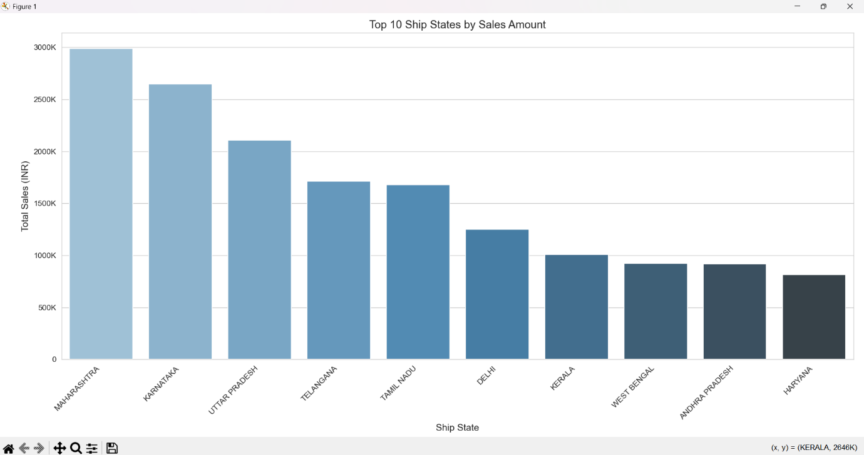

1. **Sales Distribution by Gender (Pie Chart):** This visualization uses a pie chart to illustrate the proportional sales contribution by gender. The chart includes:
   * Data aggregation by gender with sum of sales amount
   * Percentage labels for immediate proportion interpretation
   * Gender-specific colors (pink/blue) for intuitive association
   * Clean layout with appropriate title and legend

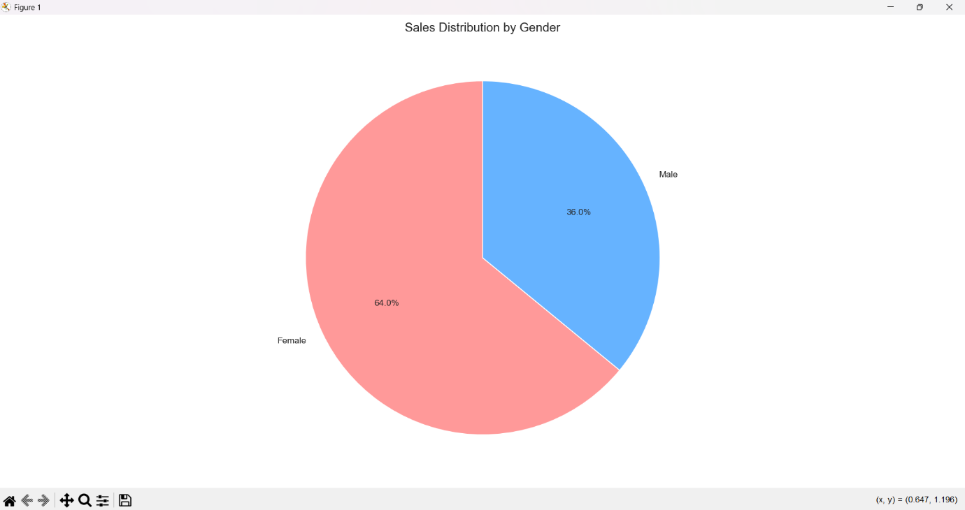

1. **Category-wise Sales Distribution (Bar Chart):** This bar chart displays sales performance across product categories, featuring:
   * Sorted categories in descending order of sales amount
   * Green color gradient to differentiate from other charts
   * Formatted y-axis for large numbers
   * Rotated x-axis labels for readability with many categories

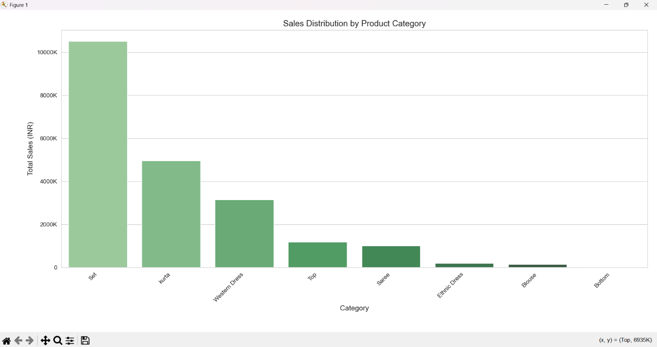

1. **Channel-wise Order Volume (Count Plot):** This horizontal count plot visualizes the number of orders processed through each sales channel, including:
   * Ordered display from most to least frequent channels
   * Purple color palette to visually separate from sales amount visualizations
   * Clear labeling to distinguish this as a frequency rather than amount metric

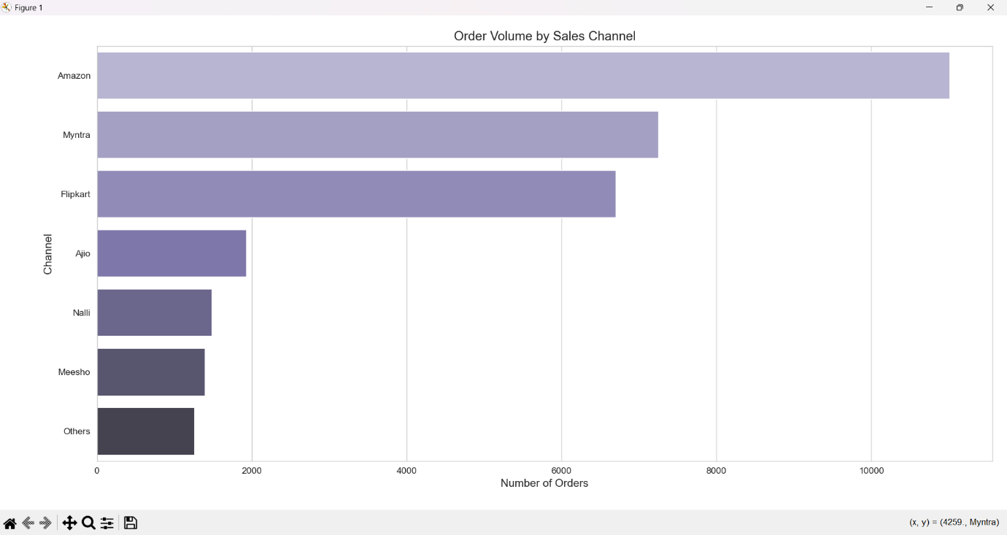

1. **Order Status Breakdown (Pie Chart):** This pie chart illustrates the distribution of orders across different status categories, featuring:
   * Percentage labels for immediate interpretation
   * Diverse colour palette from Seaborn's Set2 to clearly differentiate statuses
   * Appropriate title and legend placement

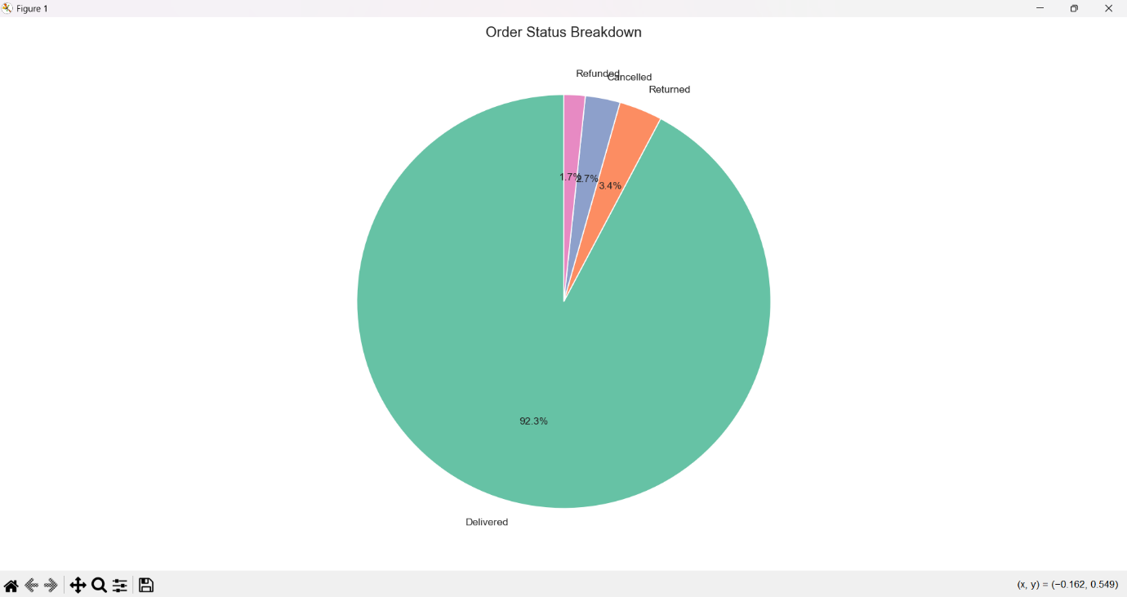

Together, these visualizations employed principles of effective data communication including appropriate color encoding (sequential palettes for intensity, categorical palettes for differentiation), thoughtful arrangement (sorted bars, strategic positioning), contextual annotation (direct labeling of values), and multi-dimensional representation (combining position, color, and size encoding). The consistent visual language maintained across visualizations—including color schemes, font sizes, and grid styling—created a cohesive visual narrative that guided viewers through progressively detailed perspectives on India's air quality challenges.

**5. Conclusion**

The comprehensive analysis of Vrinda Store's sales data has yielded valuable insights across multiple dimensions of the business, providing an evidence-based foundation for strategic decision-making. Through rigorous data cleaning, statistical hypothesis testing, and visualizations, several significant patterns and relationships have emerged that can directly inform business strategy and operational improvements.

The gender-based analysis revealed important differences in purchasing behaviour between male and female customers. The statistical significance of these differences, determined through t-test analysis, suggests opportunities for more targeted marketing approaches and potentially gender-specific product offerings or promotions. Understanding these demographic patterns can help Vrinda Store optimize its customer engagement strategies and potentially increase customer satisfaction and sales conversion rates within specific demographic segments.

Geographic analysis highlighted significant regional variations in sales performance, with the top 10 states contributing disproportionately to overall revenue. This geographic concentration of sales suggests opportunities for regional marketing initiatives, potential expansion into high-performing regions, or targeted efforts to improve performance in underrepresented areas. The clear visualization of state-wise sales distribution provides actionable intelligence for regional strategy development and resource allocation.

Product category analysis demonstrated varying levels of performance across different product lines. The ANOVA results provided statistical validation of these differences, confirming that the observed variations in category performance are not merely due to random fluctuation. This insight enables more informed inventory management, potentially suggesting categories for expansion or re - evaluation based on their relative contribution to overall sales.

The channel analysis revealed important patterns in order volume across different sales pathways. Understanding which channels generate the highest transaction volumes provides direction for channel optimization efforts and potential resource reallocation. Furthermore, the chi-square analysis of the relationship between channels and order status highlighted potential operational differences between channels that may require attention to ensure consistent customer experience regardless of purchase pathway.

Order status breakdown analysis provided insights into operational efficiency, highlighting the proportion of orders in various stages of the fulfillment process. This operational perspective complements the sales performance metrics and offers a more holistic understanding of business performance beyond pure revenue figures.

The data cleaning process implemented in this analysis also established standardized approaches to handling common data quality issues in Vrinda Store's dataset, creating a template for ongoing data maintenance and quality assurance. This improved data hygiene will enhance the reliability of future analyses and business intelligence derived from the sales data.

In summary, this analysis has transformed raw sales data into actionable business intelligence across multiple dimensions of Vrinda Store's operations. The combination of statistical validation and clear visual representation ensures that the findings are both reliable and accessible to stakeholders at all levels of the organization. These insights provide a solid foundation for evidence-based decision making that can drive improved business performance and strategic growth.

1. **Future Scope**

The current analysis of Vrinda Store's sales data has established a solid foundation for data-driven decision making, but numerous opportunities exist to extend and enhance this analytical framework in the future. This section outlines potential directions for future analysis that could provide even deeper insights and more sophisticated decision support.

**Advanced Time Series Analysis:** While the current analysis captures a snapshot of sales performance, implementing time series analysis could reveal valuable temporal patterns and trends. Future work could include:

* Seasonal decomposition of sales data to identify cyclical patterns
* Time-based cohort analysis to track customer behaviour over different time periods
* Forecasting models to predict future sales across various dimensions (products, regions, channels)
* Trend analysis to identify growing or declining product categories or regions

**Customer Segmentation and Lifetime Value Analysis:** Extending beyond basic demographic analysis, future work could implement more sophisticated customer segmentation:

* RFM (Recency, Frequency, Monetary) analysis to identify high-value customer segments
* Customer lifetime value modelling to prioritize marketing efforts toward most profitable customers
* Purchase pattern clustering to identify distinct customer personas
* Sequential purchase analysis to understand customer journey and product adoption sequences

**Machine Learning Integration:** The analysis could be significantly enhanced by incorporating predictive analytics and machine learning:

* Predictive models for customer churn prediction
* Recommendation systems based on purchase history and customer similarity
* Anomaly detection for identifying unusual sales patterns or potential data quality issues
* Price elasticity modelling to optimize pricing strategies

**Expanded Hypothesis Testing:** Building on the current statistical framework, additional hypothesis tests could explore:

* Interaction effects between variables (e.g., do different age groups respond differently across sales channels?)
* Multi-factor ANOVA to simultaneously examine multiple categorical variables
* Non-parametric alternatives for data that violates assumptions of parametric tests
* Bayesian hypothesis testing for more nuanced probability statements about business hypotheses

**Enhanced Visualization and Reporting:** The visualization component could be expanded to include:

* Interactive dashboards using tools like Plotly, Dash, or Streamlit
* Geospatial visualizations with more granular mapping of sales performance
* Network analysis visualizations for product association patterns
* Automated reporting system for regular business intelligence updates

**Operational Optimization Analysis:** Future analysis could focus more directly on operational efficiency:

* Inventory optimization modelling to minimize holding costs while maintaining service levels
* Order fulfillment process analysis to identify and address bottlenecks
* Channel efficiency comparisons incorporating cost metrics alongside revenue
* A/B testing framework for evaluating changes to processes or offerings

**External Data Integration:** The analysis could be enriched by incorporating external data sources:

* Market trend data to contextualize sales performance
* Demographic data to better understand regional performance variations
* Competitor performance data for comparative analysis
* Economic indicators to control for broader market conditions

**Automated Data Pipeline Development:** To ensure ongoing analytical capability, future work could include:

* Development of automated ETL processes for continuous data integration
* Implementation of data quality monitoring systems
* Creation of data governance frameworks to ensure consistent data standards
* Development of real-time analytics capabilities for immediate business insights

**Natural Language Processing for Customer Feedback:** If textual data is available or could be collected, future analysis could include:

* Sentiment analysis of customer reviews or feedback
* Topic modelling to identify common themes in customer communications
* Named entity recognition to extract product or feature mentions from text data
* Aspect-based sentiment analysis to understand specific points of customer satisfaction or dissatisfaction

By pursuing these future directions, Vrinda Store could develop an increasingly sophisticated analytical ecosystem that provides deeper insights, more accurate predictions, and more targeted strategic recommendations. This evolution from descriptive to predictive and eventually prescriptive analytics represents a natural progression that could significantly enhance the business value derived from their data assets.

**7. References**

* **Microsoft Documentation**  
  Microsoft Learn. (n.d.). *Documentation*. Retrieved from: <https://learn.microsoft.com/>
* **Pandas Documentation**  
  The Pandas Development Team. (n.d.). *Pandas Documentation*. Retrieved from: <https://pandas.pydata.org/docs/>
* **NumPy Documentation**  
  Harris, C. R., et al. (2020). *NumPy Documentation*. Retrieved from: <https://numpy.org/doc/>
* **Matplotlib Documentation**  
  Hunter, J. D., et al. (n.d.). *Matplotlib Documentation*. Retrieved from: <https://matplotlib.org/stable/contents.html>
* **Seaborn Documentation**  
  Waskom, M. L. (n.d.). *Seaborn Documentation*. Retrieved from: <https://seaborn.pydata.org/>
* **Stack Overflow**  
  Stack Overflow. (n.d.). *Community-driven Q&A for programming*. Retrieved from: <https://stackoverflow.com/>
* **Github**

<https://github.com/rishabhnmishra/Excel_Vrinda_Store_Analysis/blob/main/Vrinda%20Store%20Data%20Analysis.xlsx>

**8.LinkedIn Post**

**9.Github**